New Member Information
VISTA Gardens is Hillsborough County's First Garden Park, organized as a 510c3 not-for-profit corporation under FL laws. Articles of Incorporation and Bylaws are available for review on request.

The Board of Directors

The VISTA Board of Directors meets on the first Saturday of each month (except July and August). Current members of the Board are Jennifer Grebenschikoff, President; Marty Kleiner, Vice President, Keshia Arlinghaus, Secretary; Susan Baxter Gibson, Treasurer; Barb Mahlmeister, Steve Taylor, and Evans Bostick. More information about the Board is available at https://www.vistagardentampa.org/boardofdirectorsandcommitteechairs

The VISTA Board governs and makes policy, but strongly encourages operational decisions to be made at the committee level. Minutes of each VISTA Board meeting are available for review by request to the Secretary.

How the VISTA community is organized

As VISTA is a not-for-profit, active committee participation by every member is vital to community success. When you join VISTA, you are not only receiving a garden plot you also are committing to be an active member of the community. On membership approval, you will be asked to select and participate in one of the VISTA committees for a minimum of two hours a month. You are more than welcome to help more than the minimum two hours, if your time permits, and many of our members currently do.

Each committee chair has provided a description of its primary roles and responsibilities:

Communications Committee, Marc Carrillo-Perkins, Chair

The communications committee produces the monthly VISTA newsletter called “VISTA Matters.” New members should expect to begin receiving the newsletter within the first few weeks of joining. If you do not receive the newsletter, first please check your spam or promotions folders. Past issues of VISTA Matters are available on our web site at: https://www.vistagardentampa.org/news

The committee also maintains the VISTA web site: www.vistagardentampa.org, Facebook page (search and follow “VISTA Gardens”) and Instagram (search and follow “VISTA Gardens Tampa”). Please be sure to follow both if you use social media. Current garden activities, articles and events are regularly posted to those sites.

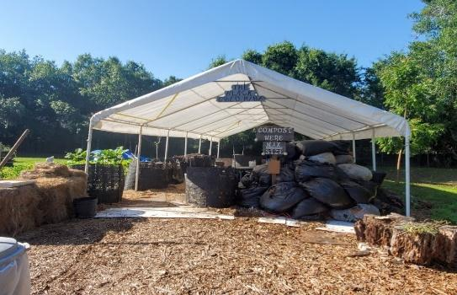
Compost Committee

The compost committee is responsible for producing nutrient rich soil amendment that we fondly refer to as “black gold.” The committee requests ongoing donations from community members and also receives material from several local programs and businesses.

We accept fruit, vegetable, coffee grounds, crushed eggshells and non-diseased plant material (no weeds or plant cuttings with fungus, mildew or insect infestation). Please add material to the designated intake compost pile and cover it with leaves (available in nearby bags).

We do not compost dairy or meat products, pits, shredded paper, biodegradable bags, large roots or sticks because they do not break down fast enough for our operation.

When adding plant material to our compost pile, smaller is better. For example, if you add a finished plant from your garden, please cut it into sections 12” or smaller.

Our compost piles decompose quickly because our committee turns and waters them very regularly. This process only works well when we all pitch in. If you are in good shape and like a good upper body workout, come help turn the pile! At a minimum, please plan to join the committee at least once each year to help turn and/or sift. (Naturally, do not feel pressured to do this if there are physical limitations that prevent your participation)

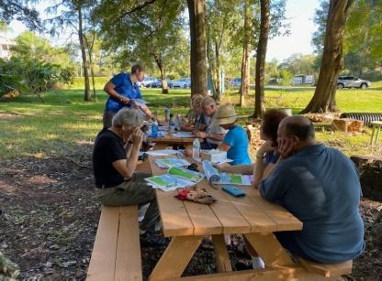
Education Committee, Barb Mahlmeister, Chair

In the past, we offered many presentations on seeding, fertilizing, harvesting and ways to trim and tend plants. We coordinate with Urban Roots, Whitwam Organics and the UF IFAS program to offer information to help you get the most from your garden experience.

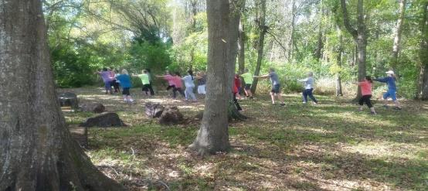
We have also presented on topics such as how to attract birds to your yard (with Wild Birds Unlimited), butterfly gardening, and nutrition. When weather allows, we enjoy Yoga at the garden.

Finance Committee, Susan Baxter Gibson, VISTA Treasurer and Chair

VISTA Gardens does not receive operating funds from the County, although the County owns the property and will sometimes help us with capital projects such as the pavilion and with smaller budget items such as new trees.

The garden is required to file a short tax form every year with the IRS, but we are a tax-exempt organization. As a 501(c)(3) charitable organization, donations to VISTA are tax deductible and very welcome.

The garden has an annual operating budget and it runs around $15,000. All of the accounting and related financial reporting functions are provided through donated services by a member.

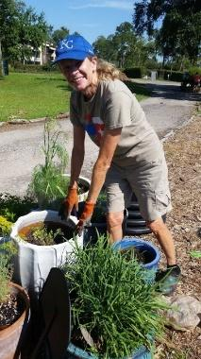
Garden Committee, Evans Bostick, Chair

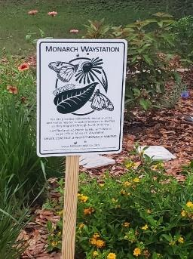
The garden committee encourages full participation of VISTA members in upkeep of the gardens, including tending their own raised garden beds and assisting with common areas – pond, herb garden, flower garden, Monarch Waystation garden, Native Plant Landscape (around the pavilion), Wildflower Garden, and the Little Free Library.

In collaboration with the Education Committee, we plan and present learning experiences for member gardeners, VISTA Social members and, in some cases, the general public.

We coordinate tours and learning experiences for community groups.

We work to sustain and continually develop a natural and aesthetically pleasing environment, focusing on native plantings.

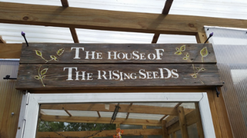
House of the Rising Seeds (HRS) Committee

When possible, we grow seedlings for members to transplant in their garden beds and request a donation of $2.00 - $4.00 per seedling to cover the cost of seeds, soil, nutrients, containers. Additionally, we provide small seed packets for directly sown plants (e.g., radishes, beets), with a requested donation of $1.00 per packet. We source our seeds carefully to ensure they are of the highest quality.

Our seedlings align with the growing seasons, including warm season plants (e.g., peppers, eggplants) and cool season plants (e.g., lettuce, peas). Quantities produced are based on past years’ experience. Watch the newsletter, VISTA Matters, for announcements of available seeds.

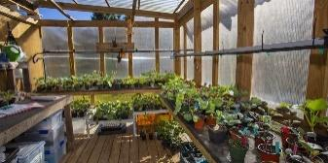
We post plant and growing information (including irrigation and fertilization suggestions) on the VISTA website at https://www.vistagardentampa.org/vegetable-information-sheets. If there is a vegetable that a member wants but our committee is not currently offering, members can seed and tend themselves to avoid buying from stores that do not offer organic seedlings.

We will help you plan your garden space, so that you have room for cool season plantings and more continual harvests. We welcome new members to the committee. The best way to learn about growing seedlings is through hands-on experience.
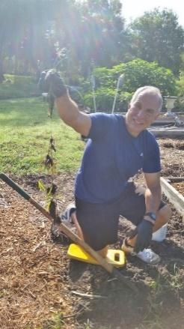
Infrastructure Committee, Marty Kleiner, Chair

The infrastructure committee performs two roles at VISTA. The first is to keep all the equipment, irrigation system, shed, pavilion, pergolas, ladders, tools, etc. in working order. The second is the creation and construction of new projects to support the other committees and enhance the overall appearance of the garden.
Tasks can be as simple as filling the wheelbarrow tires with air using a bicycle tire pump to trouble the shooting solar powered irrigation system with voltage and current meters when problems arise. In between, some typical tasks are replacing a faulty valve, regluing PVC pipe together, replacing rotted lumber on a garden plot, small engine maintenance, pressure washing, erecting temporary information signs, painting, installing rain water runoff pipe, etc.

If you have any interest or handyman experience in of the individual things mentioned above (not necessarily all) the infrastructure could use you.
Marketing, Steve Taylor, Chair

This committee works to promote VISTA Gardens in the County and seeks fundraising opportunities, like Anthony’s Coal Fired Pizza and Bonefish Grill “dining giveback” events. If you have experience in marketing or fundraising, your assistance on this committee is welcome.

Membership Committee, Keshia Arlinghaus, Chair

This committee is responsible for ensuring all garden beds are occupied and welcomes new garden members into VISTA through the VISTA Social Membership program. The committee attends to ongoing membership inquiries, provides introductory tours to prospective members, and manages the membership renewal process. They update a grid map that is posted on the shed communication board, so that you can find who is gardening where at VISTA.

The committee also provides New Member Orientation and introduces new members to their selected committees.

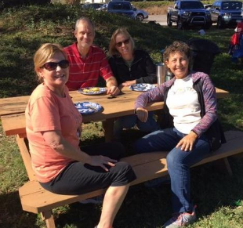
Social Committee,Laurie Kleiner, Chair

Throughout the year, the social committee provides opportunities for people to gather socially and get to know their garden buddies. Examples of successful activities include potluck gatherings, social bike rides, happy hours and local restaurant outings.

Please feel free to join the social committee and help plan future events.

Volunteers Committee, Lauren Kremenova, Chair

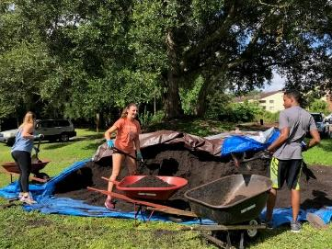
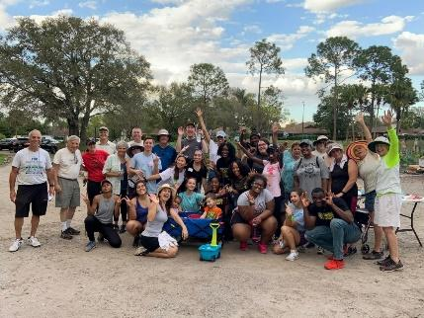
The Volunteers Committee welcomes groups of high school students to the garden on most Saturdays to help us with general garden maintenance, and them with gaining their required volunteer hours. In addition, local colleges and community groups sometimes volunteer for special projects.

This is a great committee for anyone who enjoys working with groups of enthusiastic people looking to make a difference in their community.

Wildflower Garden Committee, Roberta Owens, Chair

A landscape demonstration garden of Florida Native plants, including trees, shrubs, grasses, and wildflowers has been developed along South Village Drive to enhance VISTA’s entrance, increase the bio-diversity of benefit to our vegetable gardens and the environment generally, and to reach out to our larger community about the value of landscaping with native plants. Members of our committee select one to three varieties of plants about which they become “Resident Experts” and regularly tend the plants in this garden. As the garden is established (2021-2022) more visitors will be welcomed and tours be held when our Resident Experts can share information about the garden and plants.

Membership

As a new member you agreed to the following commitments when you signed and submitted your membership application:

Commitments

- Learn and practice sustainable and organic gardening. Following are resources community members find helpful:
- Month-by-month planting and garden maintenance guide: http://edis.ifas.ufl.edu/ep450
- Vegetable Gardening Guide: https://7f72b1de-8f7d-41a1-80dd-4418194fc079.filesusr.com/ugd/834747_25b8ba5c94bc440abd8630a3b4573543.pdf
- Additional References and resources are available at: https://www.vistagardentampa.org/learn

- To observe reasonable safety precautions and report any unsafe conditions or activities to the Board or the relevant committee chair. https://www.vistagardentampa.org/boardofdirectorsandcommitteechairs

- To protect the property. Each time you leave the garden, please ensure the gate, shed and equipment are locked and water valves are closed. If you arrive at the garden and observe these areas are unlocked, or water valves are open, please notify a member of the Board of Directors.

- To be responsible for the safety and behavior of all guests and those you authorize to tend your plot.

- VISTA Gardens believes in the honor system. You commit to being a good neighbor and should expect your neighbors to be good to you. You commit to keeping your garden space (inside and outside) free from weeds, pests and disease and will return all shared tools to their appropriate place in better condition that you found them.

- You understand that it is necessary to summerize your raised garden bed Mid-June through Mid-August, unless you have made special arrangements with the Garden Committee to grow summer crops. To summerize, you will either plant a cover crop or cover the soil with landscape cloth. You will remove all unsecured trellis and décor that may become projectiles during hurricane season. You will assist in maintaining the pathways and other common areas throughout this time.

- You will not make changes or alterations to the community property (area outside the raised garden plots) without Board approval.

You will participate, support, or lead:
- in assisting with the physical work of maintaining common areas, amenities, infrastructure, and any vacant plots
- creating and maintaining a beautiful garden consistent with community at large
- joining and supporting a committee or proposing to the Board and implementing a Board-approved independent project
- assist differently-abled gardeners as opportunities arise
- start your garden within two-weeks of joining (or Fall season opening) and understand you forfeit use of your plot and membership fee if you do not start the garden, or if your plot falls into neglect requiring others to tend to weeds or plant disease created by inaction.

Failure to comply with any of these commitments can result in loss of raised garden bed and VISTA membership.

“We get out of it what we put into it. Gardening requires research, determination, and patience (especially with Florida’s different growing seasons and challenges).”
Marc Perkins-Carrillo, Chair-Communications Committee, member since 2019.

Welcome to the VISTA Community, we are glad to have you here. Happy Growing!

