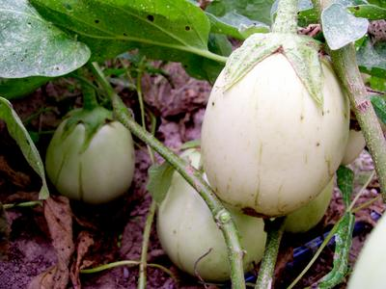
Applegreen Eggplant
Early maturing, apple-green fruits with tender skin that doesn’t require peeling. Apple- sized fruits average 3 x 2½ inches.

Spacing: 20 inches between plants, 30 inches between rows.

Irrigation: Evenly moist soil. Do not over water or allow the soil to dry out.

Climate: Transplant outdoors in full sun when soil is at least 75 degrees F.

Fertilizer: Once fruit begins to develop, apply a phosphorus-rich fertilizer like bone meal to encourage healthy fruit development. Too much nitrogen will produce lush foliage and few fruit. A balanced tomato/vegetable fertilizer works well for continued, regular feedings.

Maturity/Harvest: 65 days Keep well picked to stimulate continued production. Small fruits have the best eating quality. Fruits are ripe when the skin appears glossy and fruit is resilient to thumb pressure.

Seed source:
https://www.southernexposure.com/products/applegreen-eggplant

Eggplant is a compatible neighbor with and benefits from growing alongside many plants. It has no incompatibility issues! Read more about this in the following blog, that will surely provide inspiration for planning your garden.
https://insteading.com/blog/companion-planting-for-eggplant/

