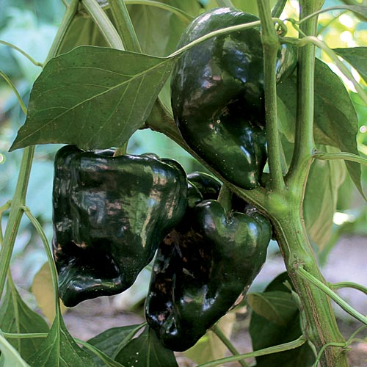
Ancho Gigantea Poblano Pepper
Distinctively rich Mexican poblano sets the standard for sauces and stuffing; it is also excellent used fresh for chile rellenos. Medium hot.
Climate: Full sun. Ideal soil temperature 65-85˚F. Peppers will do best with soil that is fertile, lightweight, slightly acidic (pH5.5-7.0) and well-drained.
Spacing: 12-24 inches apart in raised beds. Plant grows 2'2" tall.
Irrigation: Water the plants regularly, giving them at least 2 inches of water per week during dry weather. Check the soil moisture by sticking your finger into the soil; water any time it feels dry an inch beneath the surface. Irrigate the base of the plant and avoid getting water on the foliage. Keep soil moist, but not soaking wet.
Fertilizer: Avoid using high nitrogen fertilizer, or you will have more foliage and less fruit. Use fertilizer to ensure soil is rich in phosphorus, potassium and calcium.
Matures 90 days after transplant. Can be harvested when green-black heart-shaped fruits measure 4" long, or it can be allowed to ripen to red and be dried as an ancho chile.
https://www.seedsavers.org/ancho-gigantea-pepper
https://gardeningsolutions.ifas.ufl.edu/plants/edibles/vegetables/peppers.html
Peppers are compatible with tomatoes, carrots, cucumbers, radishes, squash, eggplant, spinach, lettuce, chard, onions, and peas. They benefit from the company of nasturtiums, geraniums, and petunias.

Peppers are incompatible with pole beans, mustards, soybeans, lima beans, fennel, cabbage, broccoli, Brussel sprouts, cauliflower, collards, kale, turnips, and strawberries.

