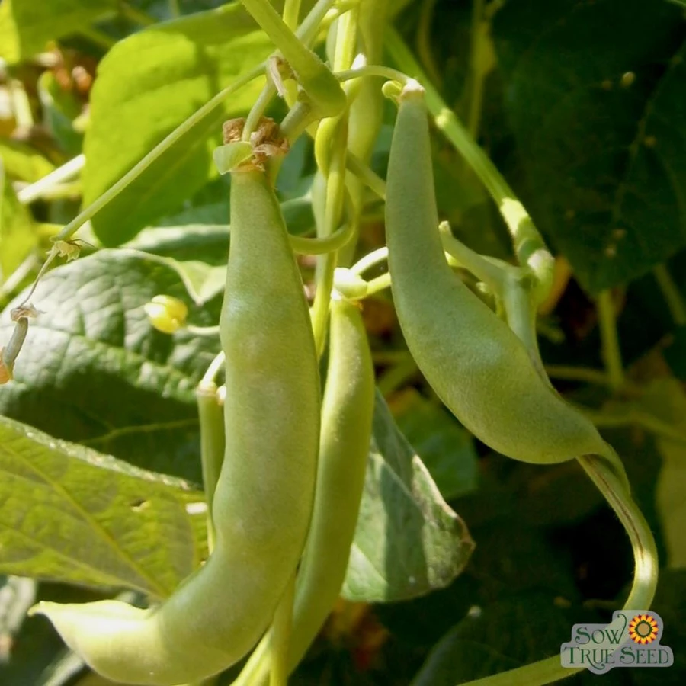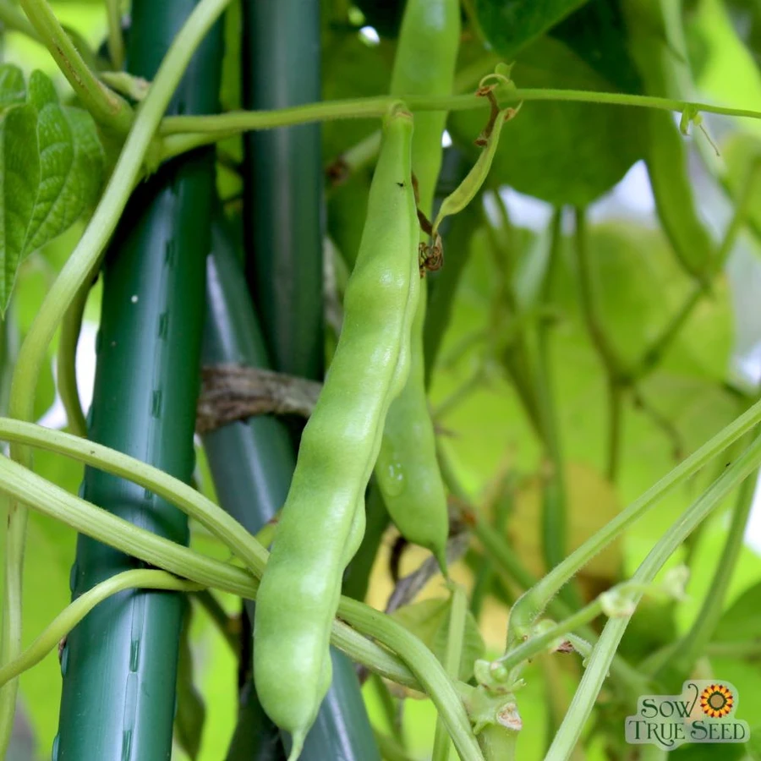
Pole Bean – Greasy*, Lazy Wife

One of the largest of all the greasy varieties, it's called Lazy Wife because the gardeners (who were traditionally the women of the family) could wait longer to harvest and get more food per harvest as these beans are just that big. Thick, fleshy, and stringless, pods remain tender until the beans are quite large. A great shelling bean as well. Originally from Madison County, NC.

Pole beans are a space saving wonder for the compact garden. The long vines take advantage of vertical space and have a continual harvest throughout the growing season, so they have higher yields per square foot than bush beans. For many people, the flavor is beyond compare as well.

Nutrients: vitamins A, C, and K, folic acid, potassium, iron, fiber.

Culture: Ideal soil temperature: 60-80°F. Beans are frost sensitive annuals that prefer full sun and rich, well-drained soil. To lessen the chances of disease and pests, alternate the location of bean plantings with a different crop each year.

Spacing: Direct sow seeds 1" deep, 2-3" apart. Press down the earth above them for good soil contact. Sow a few times a season, 2-4 weeks apart for a continuous harvest. Require high trellis structure.

Irrigation: Beans have shallow roots and need regular watering if the weather is dry. Provide adequate, even moisture, especially at flowering time. Dry soil can result in low yields and fibrous pods.

Fertilizer: Do not over fertilize with nitrogen which results in a surplus of foliage and low, delayed pod growth. A side-dressing of compost may be sufficient, although some gardeners add a low nitrogen fertilizer at the time of flowering.

Matures in 78 days

WHAT'S A GREASY BEAN?
An Appalachian favorite, Greasy Beans can be considered an acquired taste because of their long maturing time leaves them full and meaty, much different than most Americans prefer their string beans. Greasy beans are called "greasy" because they are smooth in texture and lack the peach fuzz that many green beans have. In many regions, it is said that Greasy Beans saved many lives during the great depression, and during other times of hardship when more common sources of protein like meat and eggs were too expensive for daily or even weekly consumption. Greasy beans were grown large and fat, allowing the beans to form fully in the pods to develop into an excellent source of protein, and then cooked for a long time with onions and a bit on animal fat if you had it. Delicious, wholesome, and an economical source of protein, these beans deserve a place in everyone's garden!

https://sowtrueseed.com/products/pole-bean-lazy-wife-greasy#:~:text=One%20of%20the%20largest%20of,the%20beans%20are%20quite%20large.

For companion planting benefits, grow with carrots, celery, chard, corn, cucumber, eggplant, peas, potatoes, radish and strawberries. Avoid planting near chives, garlic, leek, and onions. Pole beans and beets may stunt each other’s growth.

