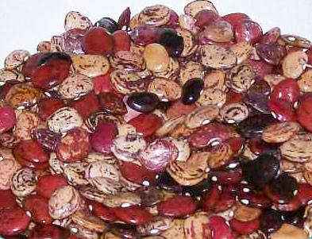

Violet’s Multicolored Butterbeans

A rainbow of colors – cream, beige, red-brown, and violet-purple, with speckles and swirls. Small seeds have great flavor, good both fresh or dried. 3-5” pods. Semi-bush plants have good disease and drought resistance. Saved by 4 generations of Violet Brady Westbrook’s family in Banks County, Georgia.

Culture: Butterbeans need a warmer soil than snap beans. Be sure the soil is well drained, moderately fertile (amended with well-cured compost) and slightly acidic, with a pH 6.0-7.0.

Note: Bean plants should be well-ventilated to promote proper development and deter mildew or mold. Beans should not be grown in the same spot more than once every four years.

Spacing: Direct sow seeds 1½" deep and 2-3" apart. Thin to 4-6"apart.

Irrigation: Water the soil immediately and regularly, providing even light moisture (not saturating soil) until seeds germinate. After germination (8-10 days) maintain soil moisture. Beans have shallow roots and need regular watering if the weather is dry. Provide adequate, even moisture, especially at flowering time. Dry soil can result in low yields and fibrous pods. Mulching with oak leaves, food grade straw or hay around bean plants maintains moisture and inhibits weeds.

Fertilizer: Do not over fertilize with nitrogen which results in a surplus of foliage and low, delayed pod growth. If you soil needs nutrients, work in a low nitrogen fertilizer (NPK of 5-10-10) at the time of planting. A side-dressing of compost or application of compost tea midway through maturity is sufficient and may not be necessary.

Mature in 80-90 days. Can be used fresh when beans fill the pod, or they can be left to dry in the pod to be used as dried beans.

https://seedracks.southernexposure.com/products/violets-multicolored-butterbeans-bean-lima-pole-seed-packet

For companion planting benefits, grow beans near carrots, cucumbers, corn or strawberries; avoid planting them near onions and fennel.

