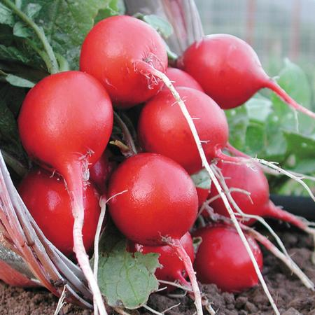
French Breakfast

Attractive 2-3" cylindrical roots are rosy scarlet with a white tip and crisp white flesh. Crisp, juicy, mild and sweet. Widely grown variety introduced prior to 1879.

Culture: Optimum soil pH between 5.5 and 6.8. Loosen top 6"of well draining soil and work compost into the top 2".

Spacing: Sow seeds 1/4" deep in moist soil, 3-4" apart, in rows 8-12" apart. Germinate in 4-10 days. Planting successively every week allows for continuous harvesting.

Irrigation: If plants do not receive one inch of rain weekly, water deeply. Drought stress can cause the roots to develop poor flavor and a tough texture.

Fertilization: Radishes do not require additional fertilization after they are planted. Be careful not to use nitrogen-rich fertilizers near radishes, as you will prompt leaf growth at the expense of radish root.

Maturity: 23 days.

https://www.vermontbean.com/product/V03350/90

Plant radishes near beans, beets, celeriac, chervil, cucumber, lettuce, mint, parsnip, peas, spinach, squash, and tomatoes. Avoid planting near potatoes.

