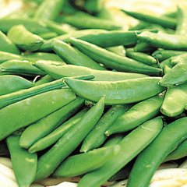
Sugar Ann – Edible Podded Sugar Pea
Sugar Ann snap pea is an early maturing dwarf variety, reaching only 2 feet in height. No staking required. The large edible pods are sweet and crisp. Disease resistant to Fusarium 1.

Culture: Cool season annual. Prepare fertile, well-drained soil. Sow seeds in in fall 8-10 weeks before first frost date or early spring after last frost. Ideal germination temperature is 65-70˚F.

Spacing: Direct sow seed 1 inch deep and 3-4 inches between each seed. When growing lots of peas, plant in rows 18-24” apart.

Irrigation: Keep soil moist. Heavy watering during flowering can interfere with pollination.

Fertilizer: Fertilize as needed with a balanced fertilizer. Too much nitrogen will produce lush foliage and result in poor flowering and fruiting.

Matures in 55-60 days.

Harvest when pods begin to swell. Harvest frequently to keep plants producing. When left on the vine too long, the peas become starchy and the pods become tough.

https://www.kitazawaseed.com/seed_605-101.html

Compatible with many plants, including bean, carrot, cucumber, eggplant, radish, leafy greens (lettuce, spinach, etc.), tomatoes and turnips. Incompatible with any member of the Allium family, so plant peas in a separate part of your garden from leeks, onions, scallions, and shallots.

