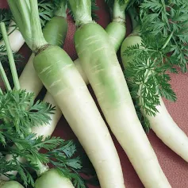
Lunar White, Organic
Lunar White carrots have been grown since the 1600’s, and they are still being grown for a good reason. This carrot is very mild and so delicious. Pure white and nearly coreless.

Culture: These long, slender carrots appreciate deeply worked, loose soil in order to reach their full length. Build up a raised mound in the row about 8" wide, sow the seeds on it, and cover them with ¼-inches of very loose soil.

Spacing: Sow seeds ¼-inch deep (see above). After germination, when they reach 2-inches in height, gently thin them to be 4-inches apart. Cut rather than pull, so that you do not disturb neighboring carrot roots!

Irrigation: Carrots like good drainage and regular watering, although the soil should be moist and not saturated. It is important not to allow soil to dry out.

Note: When the tops of the carrots begin to emerge form the soil, cover them with soil or organic mulch to keep them tender. Keep weeds under control to avoid carrots from becoming stunted.

Fertilization: When carrot tops are 3" high, apply fertilizer that is low in nitrogen and higher in potassium. Excessive nitrogen results in carrot roots cracking and splitting.

Maturity: 85-100 days. Eat fresh, juice or add to stir-fries, curries, salads, and soups.

https://www.everwilde.com/store/Organic-Lunar-White-Carrot-Seeds.html

Carrots are compatible with beans, Brassicas, lettuce, onions, peas, peppers, pole beans, radish, and *tomatoes.

Avoid planting with dill, parsnips, and potatoes.

Generally speaking, it is a good idea to keep some space between root crops so they don’t compete for available phosphorus.

Planting carrots with aromatic herbs or onions may repel the carrot fly and its maggot. Chives also benefit carrots. Other compatible herbs include rosemary and sage.

*Carrots planted near tomatoes may have stunted roots, but will have exceptional flavor.

