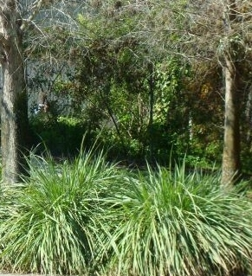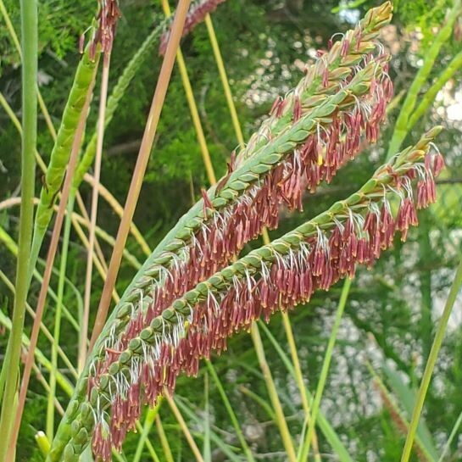

Fakahatchee Grass
Tripsacum Dactyloides
Native Floridian grass great for landscaping as an accent or border plant to add curb appeal to the property. Easy to grow and propagate and is drought tolerant, even though it is frequently found growing on river banks, hammocks, swamps and other wet sites.

Tall, green, grass-like foliage rising upright to form large clumps that grow from 4 to 6 feet wide and tall. The leaves have sharp little teeth along the edges. Flowers appear in late spring on spikes that rise above the leaves. The flower colors can be white, pink, yellow or rust.
Fakahatchee grass is the larval food plant of the Byssus Skipper butterfly and its seeds are consumed by birds.

https://www.wilcoxnursery.com/?s=Fakahatchee+Grass

