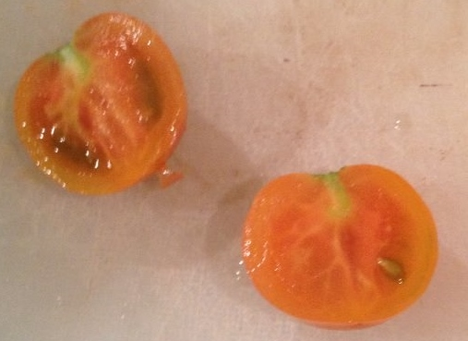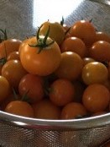
Karen, Hybrid
This sweet, fruit-like flavored cherry tomato first volunteered from Karen Rose’s compost bin and she’s saved seeds each year since. The tomato on top of those in the colander is a “Karen”. The others are Sungolds. Karen’s are bigger and usually have less seeds. Cut them in half and sauté or make tomato soup. “I make orange tomato and peach summer soup that is outrageous.” KR

Indeterminate: Train to a vertical support

Vigorous plants start yielding early and bear right through the season.

Space seedlings 18-20 inches apart. Transplant so that soil level is just below the lowest leaves.

Fertilize as needed. Too much nitrogen will produce lush foliage and few fruits.

Maturity/Harvest: 60 days after transplant

Tomatoes are incompatible with broccoli, cauliflower, corn, and dill. Carrots grown with tomatoes will have good flavor but stunted roots. Compatible with basil, beans, chives, cucumbers, garlic, lettuce, marigolds, nasturtium, onion, parsley, and rosemary; all of which help control pests.

