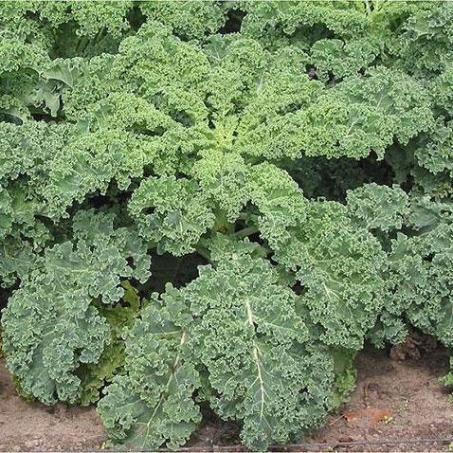
Dwarf Blue Curled Kale
Heavily crinkled leaves make fine kale chips and hold up well after harvest. 12-14" high plants with a wide spread of plumage. Slow to bolt, cold hardy & overwinters well.
Grows best in well-drained soil with compost and available nutrients like nitrogen. Add compost to ensure that the seedlings will have food immediately available to them once transplanted. Avoid planting where any member of the cabbage family grew the year before.
Spacing: Transplant each seedling 12” apart.
Irrigation: 1-1 ½ inches of water per week. Soil should be moist down to an inch into the soil.
Fertilization: Apply side dressing of compost, fish emulsion, or fertilizer every two weeks to push the plants along in production and keep them healthy.
Mature in 55 days. When leaves reach desired size, clip them off the plant using a pair pruning shears or scissors. Pick the outer leaves as needed and leave the central bud since it will grow new leaves. Store kale in an airtight bag in the refrigerator for 5-7 days. Wash when ready to use.
Kale is compatible with beets, celery, cucumbers, dill, lettuce, nasturtium, onions, spinach, Swiss chard, and many herbs (especially in the mint family). It is incompatible with tomatoes and strawberries.

