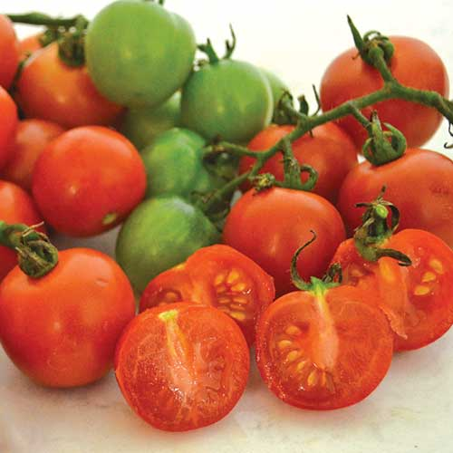
Tommy Toe, Heirloom
Exceptionally vigorous plants yield large, apricot-sized red cherry tomatoes throughout the season. The superb flavor won it top billing over 100 other varieties in an Australian taste test. Disease resistant to Fusarium Wilt, Verticillium Wilt, Root Nematodes, Tobacco Mosaic Virus. Many VISTA gardeners enjoy growing and harvesting this tomato with consistent success. Excellent for kabobs!

Climate: Transplant when soil temperature is at least 60°F.

Spacing: Space seedlings 24 inches apart. Transplant so that soil level is just below the lowest leaves. Train to vertical support or set cage into ground immediately after transplanting.

Irrigation: Water early in the day if the top 1 to 2 inches of soil feels dry to the touch. Never allow the soil to become either too soggy or too dry. Keep soil evenly moist throughout season. Excess water causes cracking.
Fertilizer: Granular Nature Safe 5-6-6 and Blood Meal, along with Compost Plus, Micros Plus, and Capacity Plus, used at VISTA at the beginning of the Fall season are good starter fertilizers. Continue regular feeding with reduction in nitrogen, using a fertilizer with more phosphorus and potassium that also contains calcium.
Matures 70 days after transplant.

https://www.seedsavers.org/tommy-toe-tomato

https://gardeningsolutions.ifas.ufl.edu/plants/edibles/vegetables/cherry-tomatoes.html

Tomatoes are incompatible with broccoli, cauliflower, corn, and dill. Carrots grown with tomatoes will have good flavor but stunted roots. Compatible with basil, beans, chives, cucumbers, garlic, lettuce, marigolds, nasturtium, onion, parsley, and rosemary; all of which help control pests.

