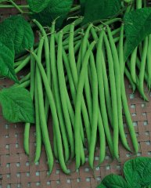
Bush Bean - Maxibel

One of the best quality French filet bean variety on the market with pods 7" long and straight. Good yield. Disease resistance to Anthracnose and Bean Common Mosaic Viruses.

Culture: Fertile, well-drained soil.

Spacing: Direct sow seeds 1" deep, 12-14" apart. Press down the earth above them for good soil contact. Sow a few times a season for a continuous harvest.

Irrigation: Beans have shallow roots and need regular watering if the weather is dry. Provide adequate, even moisture, especially at flowering time. Dry soil can result in low yields and fibrous pods.

Fertilizer: Do not over fertilize with nitrogen which results in a surplus of foliage and low, delayed pod growth. A side-dressing of compost may be sufficient, although some gardeners add a low nitrogen fertilizer at the time of flowering.

Mature in 55-60 days Harvest filet beans when diameter is 1/8-1/4" and before beans start to bulge in the pods. Harvest frequently for increased yields.

https://www.kitazawaseed.com/seed_503-4.html

For companion planting benefits, grow beans near carrots, cucumbers, or corn; avoid planting them near onions.

