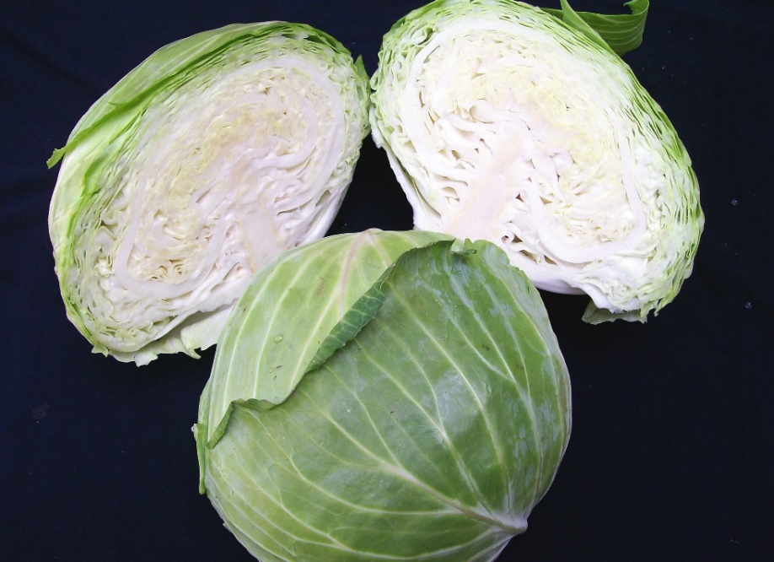
Early Flat Dutch Cabbage
Does well in southern and coastal areas thanks to its heat resistance. Excellent sauerkraut variety and the best variety for storage. Large, flat heads, 6-10 lbs, average 11 in. with medium core and few outside leaves. Sweet, mild taste.
If direct sowing, plant seeds ½” deep, 1” apart; thin to mature spacing of 18-24” in rows 24-36” apart. If transplanting seedlings, plant when 4-6 weeks old with 4-5 true leaves and set into soil deeply up to their first true leaves, especially if they are leggy or have crooked stems.
Avoid planting cabbage in same area year after year to minimize soil-borne diseases.
Fertilize: Use a high nitrogen fertilizer such as 10-3-3 when plants are established and around 6 inches tall. Add a second and final batch of fertilizer once a noticeable head forms on the cabbage plants, following the same procedure. Do not add more fertilizer after this point, as it encourages loose and/or split heads of cabbage.
Irrigation: Regular, even watering. Uneven watering can result in stunted or cracked heads. As plants reach maturity, cut back on watering to avoid splitting heads.
Matures in 85-105 days from seeding; 60-105 days from transplant.

Companion plants include beets, celery, fragrant herbs, onions, potatoes. Avoid pole beans, strawberries, tomatoes.

