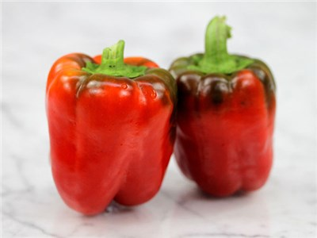
California Wonder Pepper - Sweet

After nearly a century, the largest heirloom bell pepper plant available for home gardeners. Sweet-flavored, thick-fleshed fruits that begin as glossy green, three- to four-lobed globes and then mature to a bright red. Excellent size (4-5 inches), well-formed, juicy, crunchy large fruits with good production. Culinary staples - chopped into salads, stuffed, or grilled beside fajitas –contain high amounts of vitamin A and C.

Space: Transplant 18” apart, grows to height of 18”-24”

Irrigation: Peppers require deeply-worked, well-drained soil with plenty of added organic matter and a pH of 6.0-6.8. Water deeply, but don't over water. A humidity tolerant variety.

Fertilize: Feed the plants every four weeks with a fertilizer low in nitrogen and high in phosphate and potassium or with fish emulsion, poultry manure or blood meal.

Mature 70-90 days after transplant. Cut the fruits from the plant, rather than pulling them, to avoid breaking the stems. You can harvest bell peppers once they reach full size – about 3 to 4 inches – but they will be sweeter if you wait until they turn red. Tip: Picking smaller peppers early in the season often provides a longer, more prolific harvest.

Peppers are compatible with many herbs and flowers, as well as tomatoes (although rotate where they are planted from year to year), carrots, cucumbers, radishes, squash, eggplant, spinach, lettuce and chard. Peppers are incompatible with plants in the Brassica family (Brussel sprouts, broccoli, cabbage, kale, etc.)

