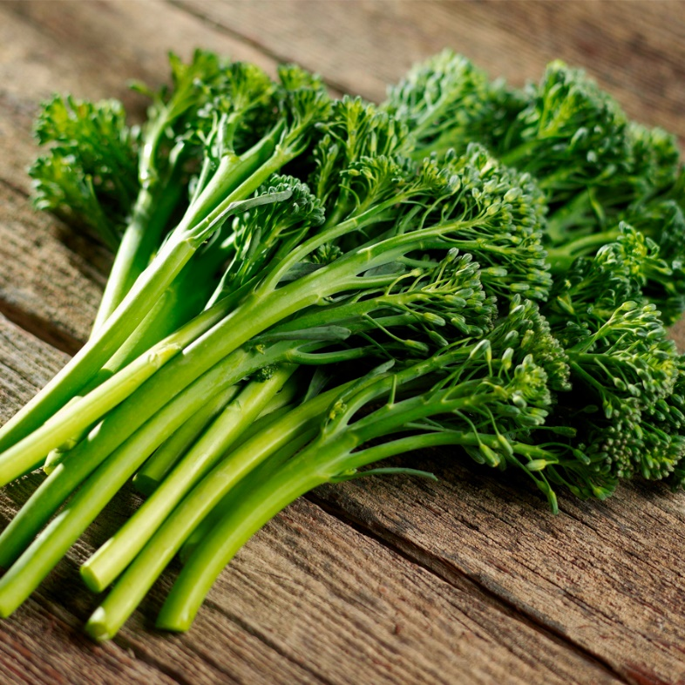
Broccoli - Aspabroc Hybrid

Known as Broccolini in the produce section of your grocery store and on restaurant menus, resembles a broccoli raab with an asparagus stem, with a mild taste. Easy-to-grow. After first maturity of the central shoots, plants will set 3 to 5 shoots shortly thereafter and continue for about 4 weeks in mild weather.

Culture: Prefers a well-drained, fertile soil high in organic matter with a pH of 6.0–6.8.

Spacing: 18-24 inches apart.

Irrigation: Prefers a consistent supply of moisture throughout the growing season. Irrigate regularly for best results.

Generally, it is best to water when the top half-inch to inch of soil begins to dry. Thick-leaved plants like broccoli will not dry out as fast. Water enough to thoroughly wet the soil and root zone, but overwatering encourages disease. Soil and foliage need time to dry, so the best time to water is early in the morning.
https://gardeningsolutions.ifas.ufl.edu/plants/edibles/vegetables/watering-the-vegetable-garden.html

Fertilizer: Use a balanced fertilizer at the time of planting and repeat three applications: 1) when plant grows to 6-8 inches in height, 2) when plant is 12-15 inches tall, and 3) when the buds first form. Broccoli also benefits from supplemental calcium in the soil. (If your fertilizer does not contain calcium, you can mix ground oyster shell or dried, crushed eggshells and into the soil at the time of planting).

Matures 50-60 days after transplant.

https://www.totallytomato.com/product/T01460/97

Compatible plants include carrot, celery, cucumber, lettuce, radish, shallot, spinach, and Swiss chard. Because broccoli is a notorious calcium-hog, plants that require little calcium (e.g. beets, nasturtiums, marigolds) are good companion plants.
Incompatible plants include peppers, mustard greens, pole beans, lima beans, snap beans, squash, and strawberries. Since broccoli is a heavy feeder, other heavy-feeding plants are not good companions (cantaloupe, pumpkin, sweet corn, and watermelon).

