Summer squash – Early Bulam
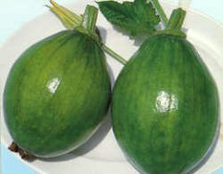
This is a Korean summer squash hybrid nicknamed avocado squash because of its appearance. If you are searching for a summer squash to grow, this is the one! It is a vigorous vine that produces oval fruit with thin, glossy, light green skin, and flesh that is similar to zucchini. They are ready to harvest as soon as 8 days after flowering. Ripe fruits measure about 4" in diameter, are 5-6" in length, and weigh about 14 oz. This hybrid delivers superior flavor—better than zucchini, say its loyal fans. Suitable for greenhouse and open field growing.

Warm season annual that matures in 65-70 days

Cultivation: Squash prefers warm temperatures. Prepare fertile, well-drained soil. Sow seeds in spring/summer after last frost in a warm, sunny location. Hill planting: Form soil into a 1-ft. diameter mound 3-4" tall. Space mounds 3-4' apart. On each mound plant 1-2 seeds. Row planting: See spacing info in chart. Keep soil moist. Fertilize as needed. Train to climb a vertical support for better air circulation and ease of harvest or leave to sprawl on the ground.

Germination  Temperature | Seed  Depth | Seed  Spacing | Row  Distance
70-95°F | 1" | 10-12" | 48-60"

Enjoy as a freshly sliced snack, sauté, stir-fry, or even grated for zucchini bread.

https://www.kitazawaseed.com/seed_368-188.html

